During 1951-1965 the Indian cinema was witnessing the Golden Era- the period when most of the classics were produced (some of which are considered to be among the greatest ever made even today). This was a period after India just gained independence, and thus coincides with the birth of modern India. While until the 1940’s the cinema was mostly escapist and detached from the daily woes of life, with the Golden Era came many successful movies that embraced social realities and themes such as challenges faced by the working class and the chaos of urban life.
It saw the advent of renowned and legendary music directors like S.D Burman, Salil Chowdhary, Shankar-Jaikishan, Laxmikant-Pyarelal, Madan Mohan, O.P.Nayyar, R D Burman who composed magical numbers. Wonderful singers such as Saigal, Mohammad Rafi, Geeta Dutt, Shamshad Begum, Suraiya, Kishore Kumar, Lata Mangeshkar, Asha Bhosle, Suman Kalyanpur, Manna Dey, and many more ruled. I think in true sense it was an era of timeless music. They can take you back in time when romance and emotions were oozed deep into the lyrics of songs, when innocence ruled the vulgarity.
The movies of this Era are loaded with songs (with about 8 songs per movie!). These old songs make the listeners ecstatic. Some songs are heart touching, some are witty, some are amusing...you name the mood and you find a good old song. But what runs common among the movies is that their songs lyrics are full of meaningful metaphors, dialogues and narration. They are so expressive and passionate that each song has its own magical impact. The lyrics were penned with simplicity of words and expression, speaking about the deep spiritual truths about our existence and surroundings. There was pleasure in songs – whether a patriotic song, romantic song or a devotional songs, they all celebrated life.
Below are some rare gems with terrific, deep lyrics, soothing music and superb singing, that added great value to the respective movies of the golden era:

Love
Maang ke sath tumhara– naya daur
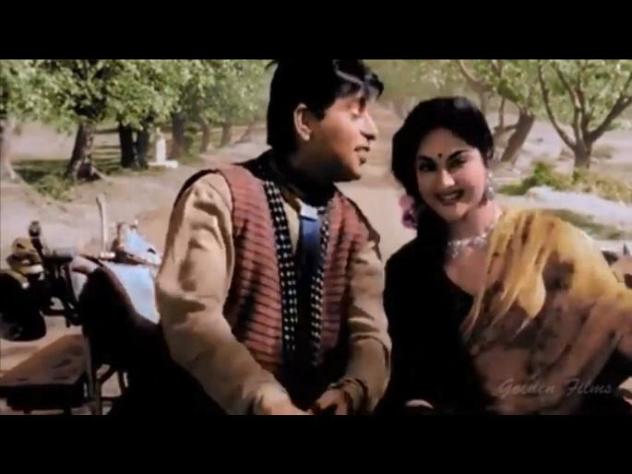
Maang ke sath tmhara
maine maan liya sansar

Pyaar kiya toh darna kya- mughale-e-azam
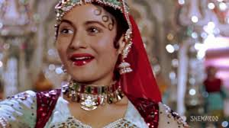
Aaj kahege dil kaa fasana
Jaan bhi lele chaahe zamana
Maut wohi jo duniya dekhe
Maut wohi jo duniya dekhe
Ghut ghut kar yun marna kya
Jab pyaar kiya to darna kya

Motivation,unity
Saathi haath badhana- naya daur

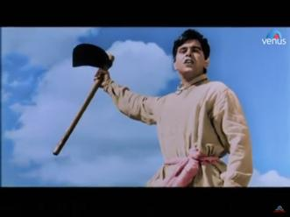
Saathhi haath badhana
Ek akela thak gaya toh
Mil kar bojh uthana

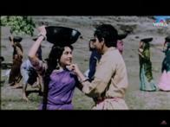

Ham mehanat walo ne jab
Bhi milakar kadam badhaaya
Saagar ne rastaa chhoda
Parabat ne shish jhukaaya

Faulaadi hain sine apane
Faulaadi hain baahen
Ham chahen to paida kar de
Chattanon mein rahe

Narration, dialogue
Mai sitaro ka tarana- chalti ka naam gadi
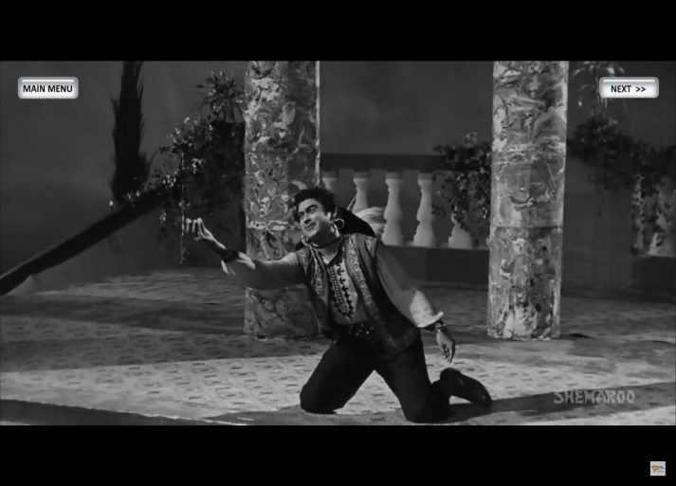
Rup kaa tum ho khazana
Tum ho meri jaan ye mana
Lekin pahale de do mera
Paach rupaiya bara aana
Paanch rupaiya bara aana aaaa
Marega bhaiya naa
Naa naa naa aaaa

Ham the woh thi- chalti ka naam gadi

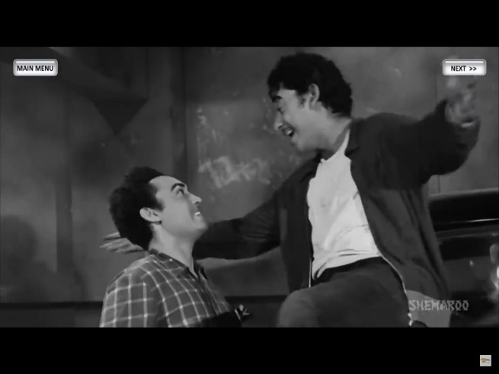
Ham the woh thi woh thi ham the
Ham the woh thi aur sama rangin
Samaj gaye naa tarrara
Jate the japan pahunch gaye chin
Samaj gaye na
Yane yane pyar ho gaya

